**Understanding & Customizing Predefined Harness Rules**

**Harness :**

**Understanding & Customizing Built in User Interface/ Harness:**

**Flowaction: Container of single section**

**Harness : Container of Multiple Sections (Harness is a Collection of One or More Sections). Harness is a UI Rule.**

**4 Types of  Predefined Harness:**

* **New Harness ( Editable)**
* **Perform Harness ( Editable)**
* **Confirm Harness ( Read Only)**
* **Review Harness (This cannot be modified. This is for system Internal Usage)**

**In Transaction Life Cycle : 3 Different Harness will be loaded**

**1-Before WO Display - New Harness ( Editable)**

**2-During WO Display- Perform Harness ( Editable)**

**3-After WO Display - Confirm Harness ( Read Only )**

**How to Debug User Interface ?**

**We can Use Live UI Tool**

**--**

**New Harness**

* **New Harness gets displayed when we run a flow. ( by default New harness is disabled)**
* **New Harness will display before a case gets created.**
* **This is been called under process tab of the flow**
* **The display of New Harness depends on a check box “Skip Create Harness” under Process tab of flow.**

**New Harness is Responsible for Creating WO. When we run case type and click on Done button in New harness the below activities gets executed.**

* **NewFromFlow/New:  Call a Work flow and executes it**
* **Add/AddWork: Responsible for creating case**
* **Generate ID: Responsible for Generating Case Numeric value based on prefix.**
* **SaveNew : Saves the case to differ queue.**
* **WorkCommit: Commits case to work table.**

**Req: Customize New Harness to Display Customer search functionality.**

**- Include Customer Search functionality in New Harness**

**- If Customer is available then ignore collecting Customer Information & Display Transaction Details**

**- If customer not available then display customer Form.**

**How to Enable/load New Harness:**

**Open Insurance flow -> Go to Process Tab**

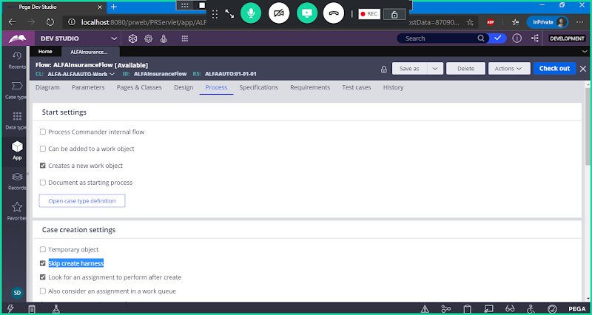

**Disable Skip Create Harness**

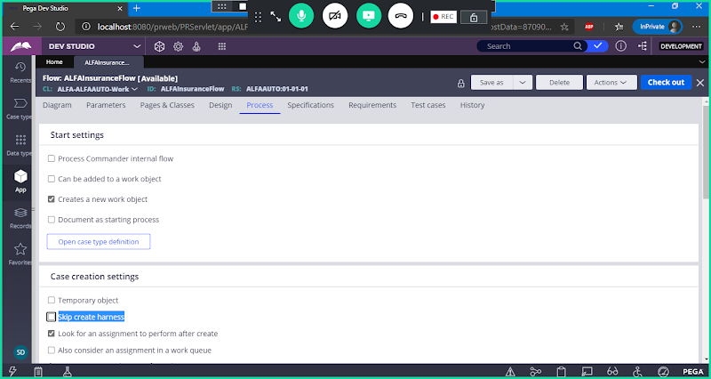

**Save**

**Scroll Down & Open New Harness from Process Tab:( Under Case Creation settings)**

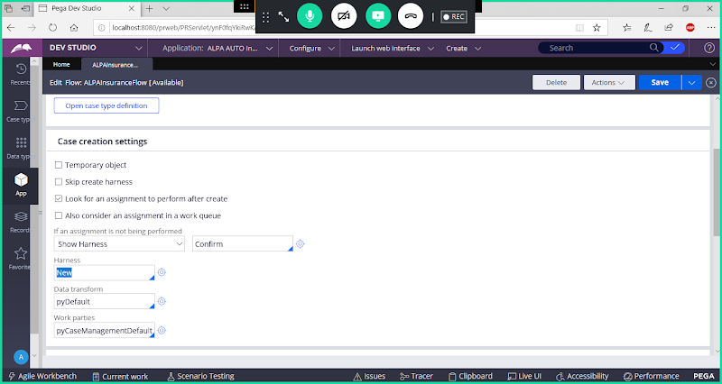

**Click on Circle to open new harness:**

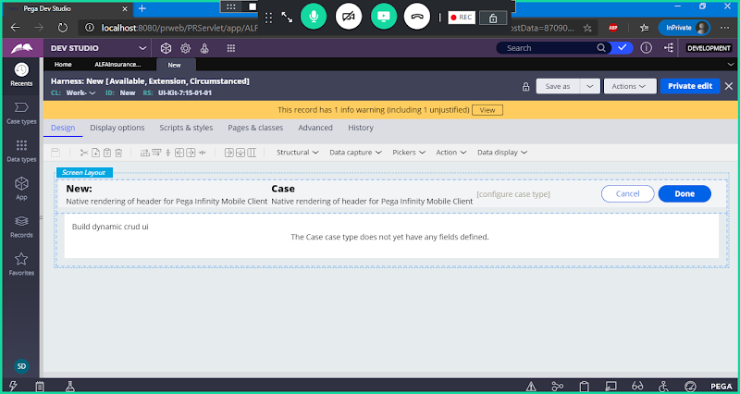

**Use Save as Option**

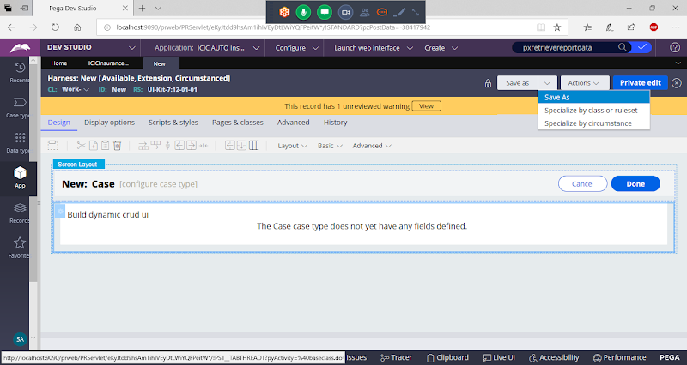

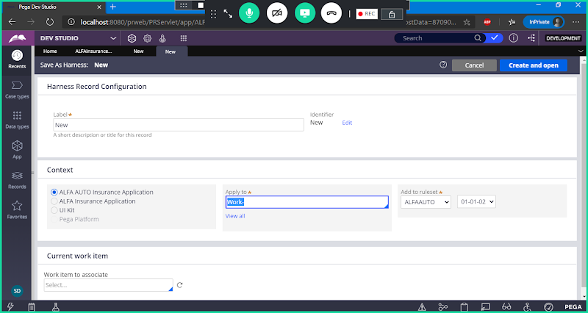

**Don't Change Label/Rule Name**

**But Change Class Name to : Class group Name**

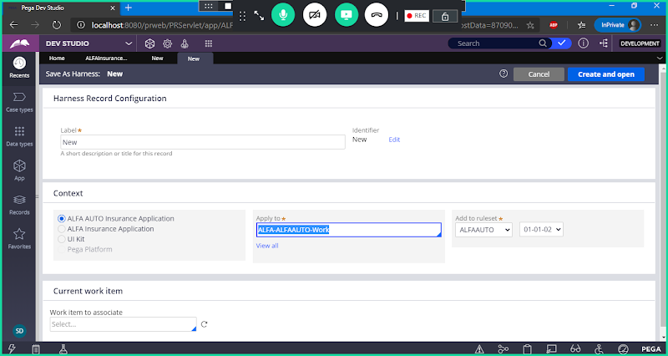

**Open**

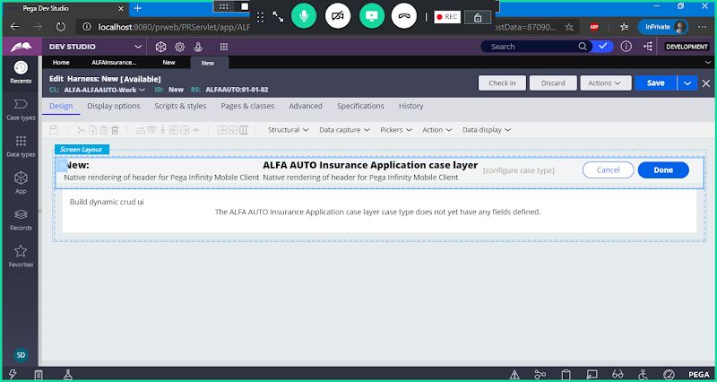

**Double Click on Panel 2 Properties**

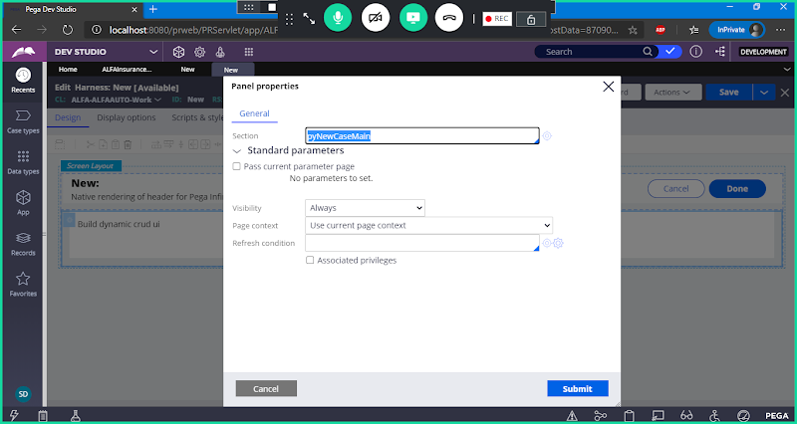

**Remove Default Section**

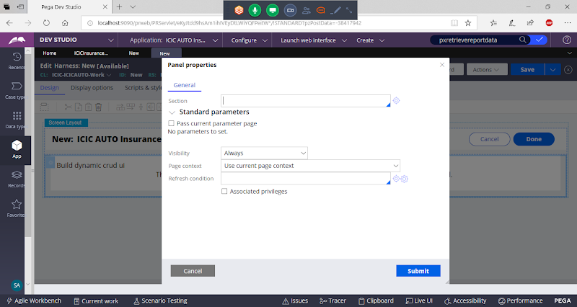

**Replace Existing Section with Customer Search section**

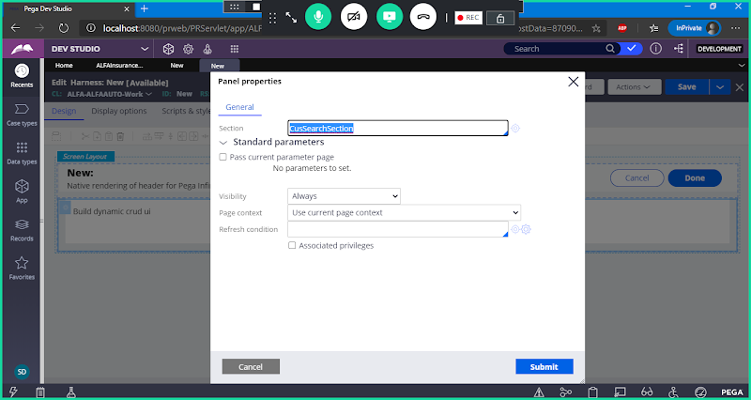

**Submit**

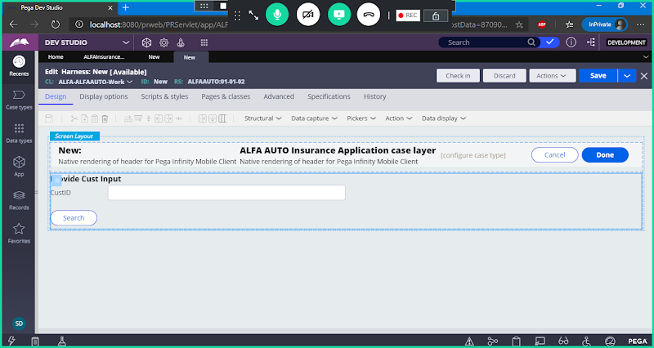

**Save Harness & Check in**

**Add Decision Condition in Insurance Flow:**

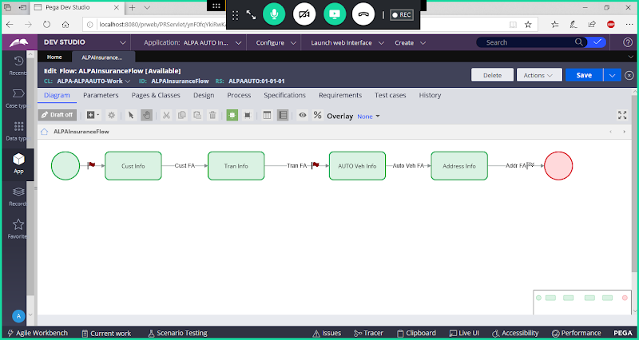

**Add Decision Shape after Start shape**

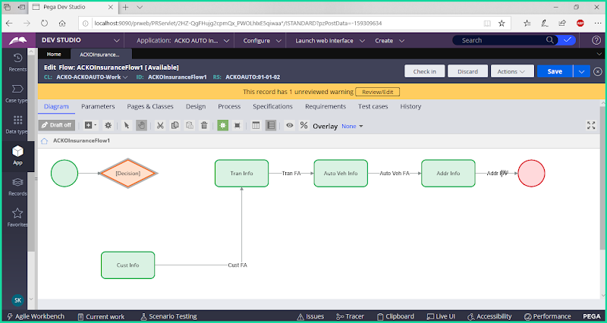

**Open Decision shape Properties**

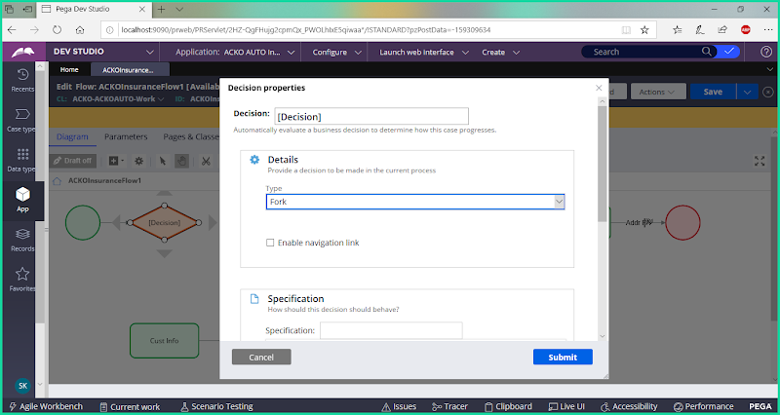

**Under Type select : Boolean Expression**

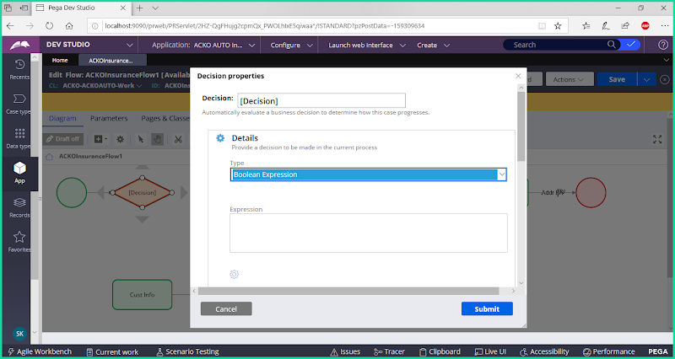

**Open Expression Builder ( Click on Settings icon)**

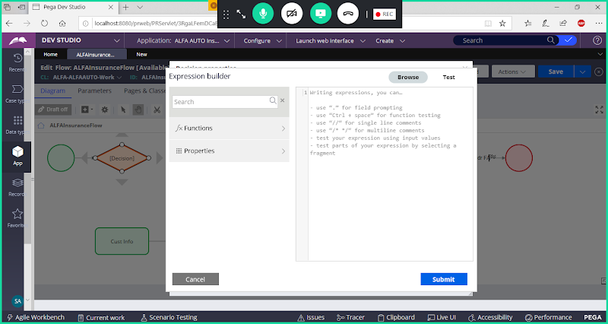

**Add Function: equalsignorecase**

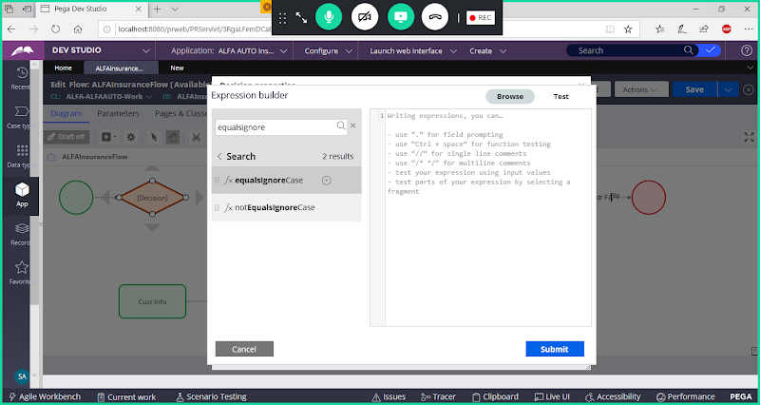

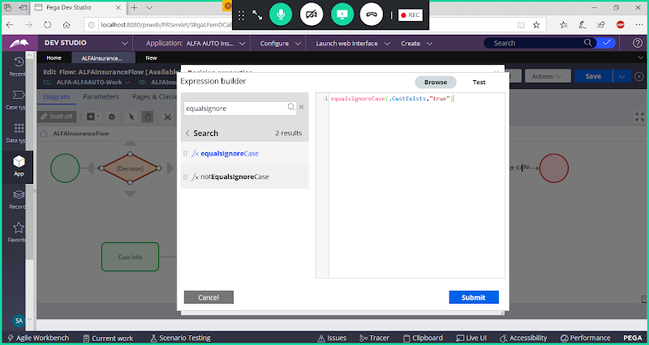

**Submit**

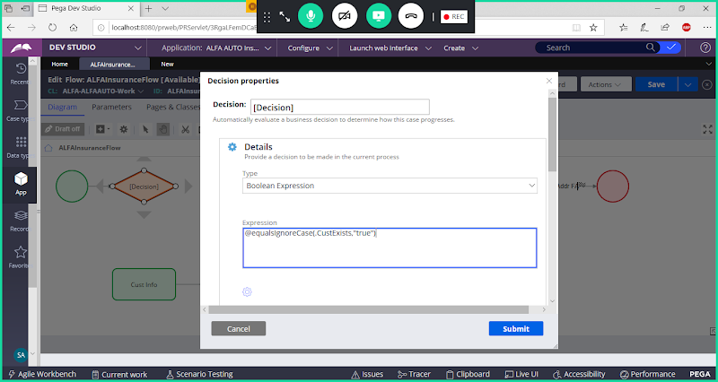

**Submit**

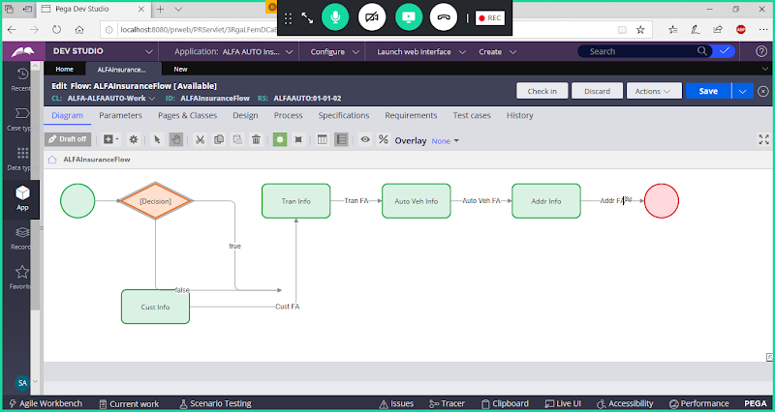

**Add True Connector towards Transaction Form & Add false  connector towards Customer Form :**

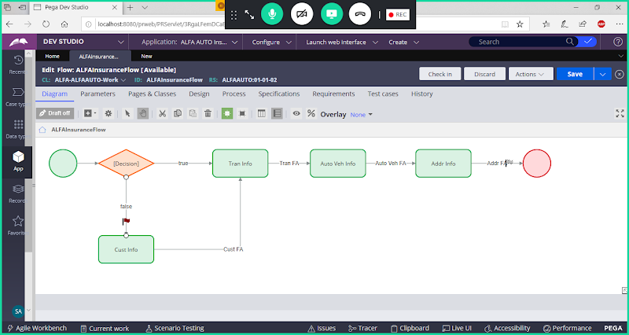

**Save Flow**

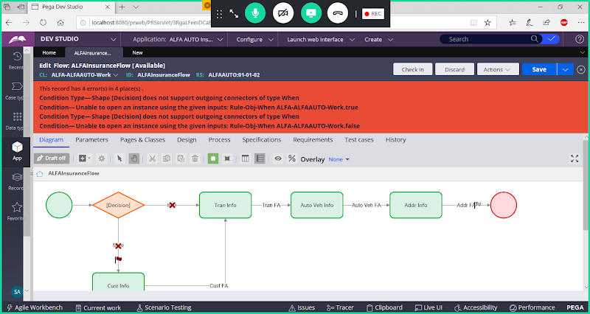

**To Resolve above error,**

**Open True Connector & Click on Submit**

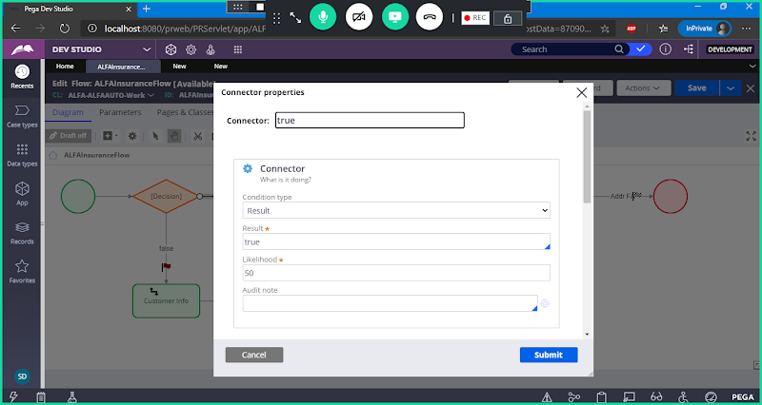

**Open Flase Connector & Change  Result to else**

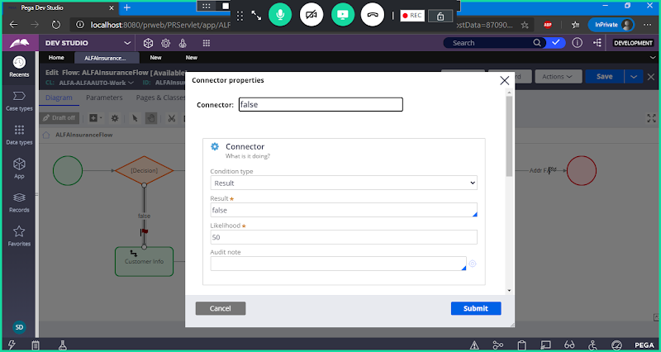

**Change Condition Type to : Else**

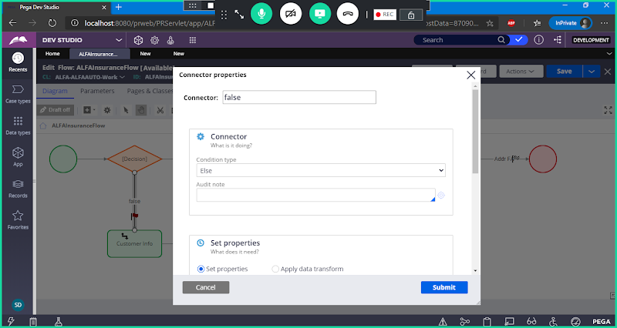

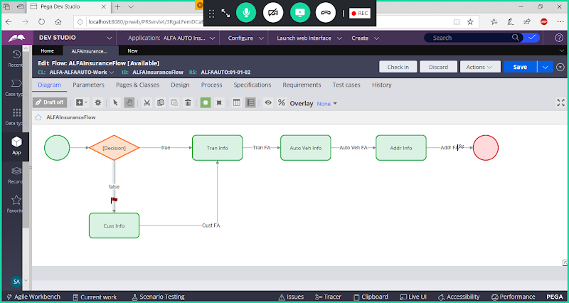

**Save & Check in & Run the flow**

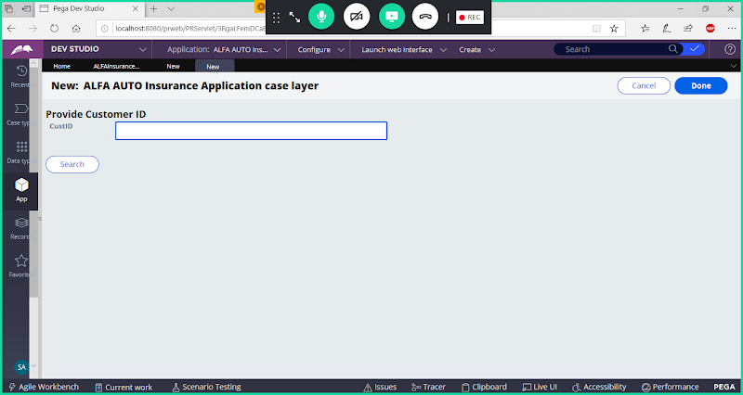

**Enter Valid Cust ID & Search**

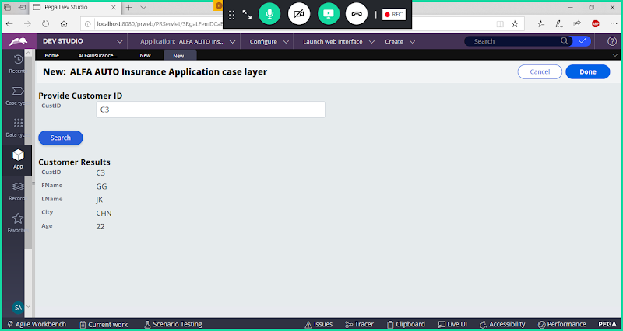

**Click on Done, it should display Transaction form**

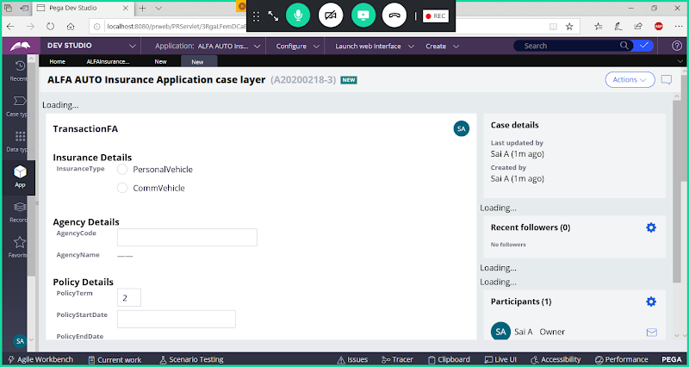

**If Customer is not available means it should display Customer form.**

**==========**